# Task 1

The PlayStation.com website attracts millions of users each day and it is critical that the site functions and looks flawless. The slider at the top of the site's home page has rich UI functionality and you are required to write a complete set of test cases to test the slider. (Please open the Playstation.com to see full slider functionality)

## Technical Requirements

1. Please submit your cucumber test scenarios as feature files or spreadsheet or in an online tool.
2. We do not care about a complete/perfect solution.
3. We expect you to use WebdriverIO and Cucumber.
4. You must be able to present your automated tests either through your preferred hosting platform (e.g. AWS) or via a local host server

## Submission Requirements

Please submit the following to us:

* Your manual test scenarios.
* Your automated test script.
* Share your code via GitHub

**Interview:** If selected for interview you will demo and present this to us and talk through your approach

## Notes

Site : [PlayStation.com](https://www.playstation.com/en-in/)

Slider Functionality

* Contains 5 top games
* 5 second rotations on the display panel for each game
* Slow slide up of Game Description text on the display panel in each rotation
* The slider icons pop up slightly as we hover over it. It doesn’t do so, when the game is clicked. So, ONLY when the mouse is hovering over the slider icon.
* Mouse pointer changes to a hand pointer when it hovers over the slider.
* When the user hovers over the slider icons, the selected game is bright (i.e., normal opacity ). But the rest of the slider icons are dimmer. This also applies when the 5 second rotations are on.
* Clicking on the slider icon puts that game on the display panel with respective content ( *Find out more,* which opens up the PlayStation.com/en-gb/games/XXX URL )
* Clicking on the slider icon also assigns a blue border that indicates that the particular game was selected. This doesn’t get de-selected even if the user clicks on other parts of the page. The blue border logic begins from the first game on the left when the page is refreshed.
* Even when the 5 second rotation is off, if the user hovers over one of the slider icons, that particular icon becomes bright and the rest of them are dimmer.
* Looks like when the user clicks on one of the slider icons ( without even having to explore the game ), the 5 second rotations stop. You have to refresh the page for this to restart.

Contents of the Slider:

1. Each hour/day one of the slider icons change?
2. Top Games?
3. Hot news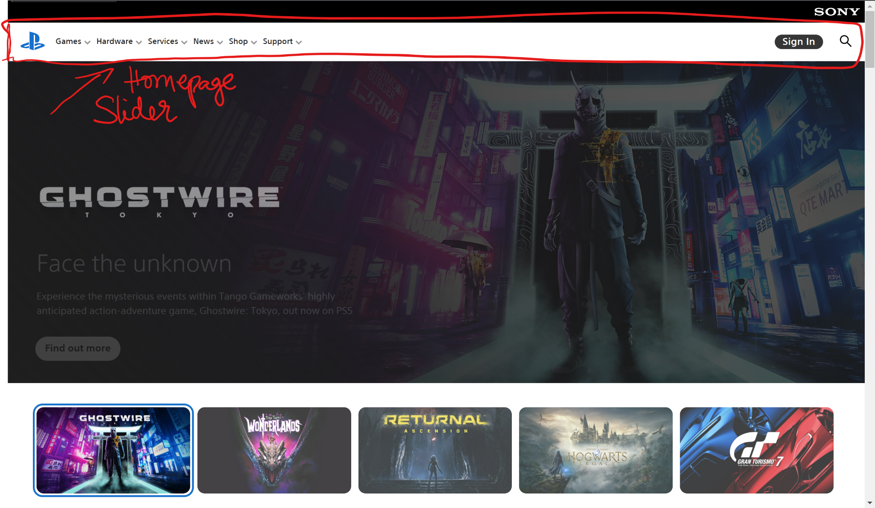



## 

Look out for :

1. Navigation bugs
2. Delay time
3. Focus on first slide
4. Accessibility
5. Cross-browser ( + size + device ) compatibility

## Questions

1. **What is a ‘slider’?** A slider is a term that refers to a slideshow on a website.A homepage slider shows consumers what their options are, and gives an overview, helping them to decide what action to take next.
2. What are the games that get selected for the slider?
3. Where does the slider content come from? What would happen if the source of the data crashes? Any scope for cache?
4. **How to test the UI slider?** Testcases -> Add script.
5. **What is a feature file?** WebdriverIO framework component
6. What are the requirements of this module?
7. How will millions of visitors impact this feature?

## Assumptions

1. Security requirements are met
2. Only valid data is sent to fill the contents of this URL ( except for the unit test testcase )
3. Current design is set after good research to attract/engage users

# TODO

* ~~Identify things to learn~~
* ~~Learn about UI Testing~~
* ~~Specify Requirements~~
* ~~Identify functions that might be used for both the tasks~~
* ~~Identify test cases~~
* ~~Complete Info section of Test Plan~~
* ~~Complete Test cases in Test plan~~
* ~~Complete Metrics in Test plan~~